MD 43.078
SAUTER Declaration on materials and the environment
Product
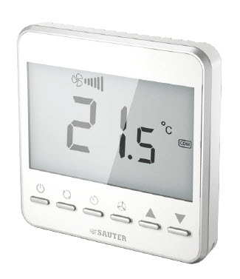 | Type | NRFC413MF111  NRFC422MF111  NRFC423MF111  NRFC424MF112
 | Designation | Modbus fan coil thermostat
 | Product range | Intelligent unitary control,  heating and air conditioning
 | Product group of eco-balance | Building management – HVAC
Manufacturer | Fr. Sauter AG  Im Surinam 55, CH-4058 Basel
Management system certified according to |  | Since | With
 | ISO 9001:2015  ISO 14001:2015  ISO 45001:2018 | 10 Oct. 2018  10 Oct. 2018  10 Oct. 2018 | SQS  SQS  SQS
Environmentally-compatible product design | Basis | Management system  Fr. Sauter AG
 | Process | Business process  - Product innovation  - Ecological accounting

Product description | CE conformity,  function, operation, maintenance, servicing | See:  PDS 43.078
Environmental risk | Fire protection according to | EN 60695-2-11, EN 60695-10-2
 | Fire load  Hazardous substances according to  Hazardous substances according to | 4.0 MJ  RoHS 2011/65/EU & 2015/863/EU  compliant. Product category 9.  REACH 1907/2006/EC compliant.
 | Parts containing halogen (causing corrosive smoke) | Printed circuit board
 | Liquids polluting the aquatic environment | None
 | Explosive substances | None
 | Transport hazardous goods class | None
Materials
Plastic | Total weight of product | 242,2 g | Material Safety Data Sheet (MSDS) | EU waste code
PC |  | 48,1 g | Not required | 20 01 39
-
Metal
Steel of different alloys  Steel, accessories - screws |  | 25,5 g  4,8 g | Not required  Not required | 20 01 40  20 01 40
Printed circuit board
PCB assembly  - |  | 103,7 g | Not required | 20 01 36
Various
-
Packaging
Corrugated board, PAP20  Paper PAP22 |  | 37 g  23,1g | Not required  Not required | 20 01 01  20 01 01
Special components
-
Hazardous ingredients

SVHC ingredient |  | Name of the ingredient | Effective concentration per article, %w/w
CAS number | EN number | Name of the ingredient | Effective concentration per article, %w/w
7439-92-1 | 231-100-4 | Lead | <8
Link to the candidate list of ECHA
 | Note  The following materials balance and the calculation of the environmental impact relate to type NRFC413MF111

Materials balance

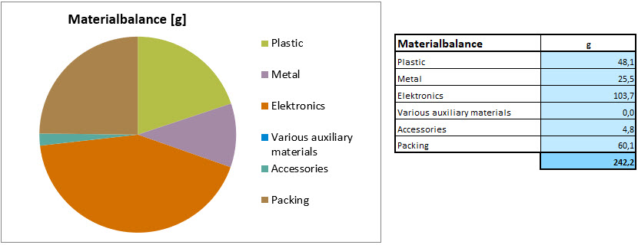
Energy requirement in the utilisation phase
Power requirement for component
Average power consumption | 5.0 | W
Typical energy consumption per year | 43.8 | kWh
The energy requirement evaluation was performed for a typical utilisation scenario. The European electricity mix from ecoinvent 2.2 was used to evaluate the power consumption in the utilisation phase.

Calculation of the environmental impact
Evaluation over the entire life stage of 8 years in a typical utilisation scenario. The results shown are based on a method of ecological scarcity that combines various environmental effects into an “environmental impact points” key figure. The method is based on Switzerland’s environmental targets and evaluates the individual effects depending on the “Distance to Target”.

Indikator | unit | production | device usage | disposal | Total
Global warming potential (GWP), IPCC 2007, 100a | kg CO2 eq. | 11 | 193 | - | 204
Cumulative energy demand (non-renewable resources) | MJ eq. | 191 | 3.900 | - | 4.090
Cumulative energy demand, renewable resources | MJ eq. | 13,4 | 296 | - | 309
Acidification potential, CML 2001 | kg SO2 eq. | 0,26 | 0,79 | - | 1,05
Eutrophication potential, CML 2001 | kg PO4-- eq. | 1,28E-01 | 6,31E-01 | 0,00E+00 | 7,59E-01
Ozone creation potential, CML 2001 | kg C2H4 eq. | 1,08E-02 | 3,19E-02 | 0,00E+00 | 4,27E-02
Ecological scarcity 2006: Total | UBP | 36.000 | 197.000 | - | 232.000,0

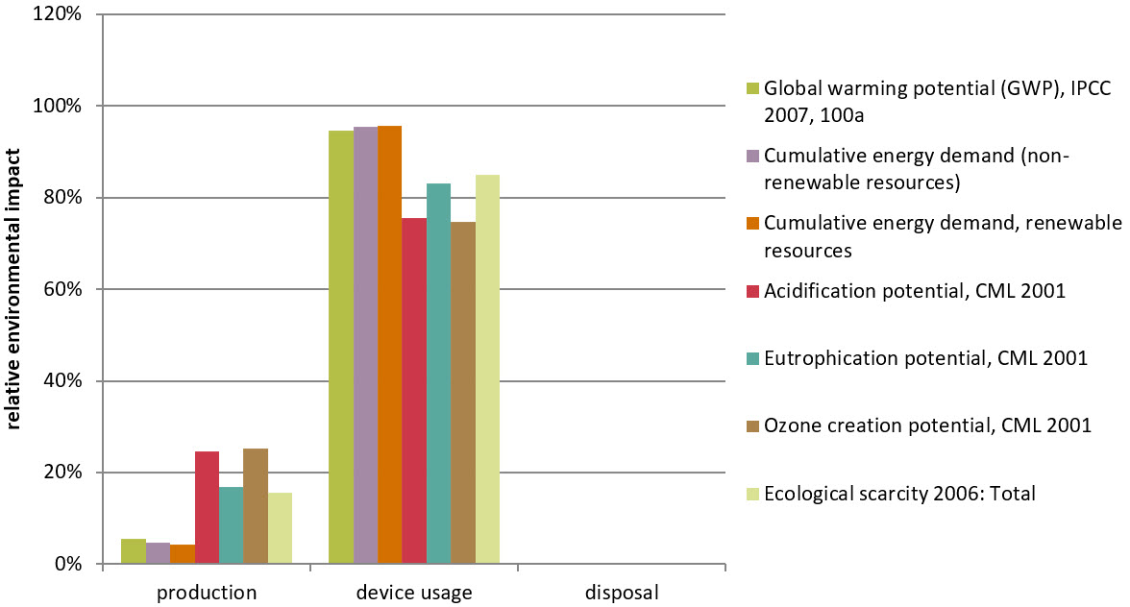

The relationship of the contributions made by the utilisation in comparison to those made by the reduction and disposal depends on the intensity of the utilisation (utilisation scenario).

 Disposal | Product:  The device must be disposed of as waste from electrical and electronic equipment (electrical/electronic scrap) and must not be disposed of as household waste. This applies in particular to the assembled PCB.  Special treatment for special components may be compulsory by law or may make ecological sense.  WEEE (Waste Electrical and Electronic Equipment)  The local and currently valid laws (WEEE2012/19/EU) must be observed.  Battery:  If present and applicable, battery disposal fees will be paid by the importer. (See list of materials on page 2.)  Packaging:  Recyclable
How the environment benefits | With these products, we make a significant contribution to energy savings in buildings and to reducing climate change.  With only 5Wh energy consumption in standstill, the primary energy requirement is outstandingly low. Its resource-saving compact design and easy single-sort disassembly result in optimal sustainability with a life expectancy of 8 years.  The eco-balance becomes even more optimal, with the use of energy from renewable sources.
Extent of applicability | This declaration is an environmental declaration based on ISO 14025 and describes the environmental impact of the product over its entire life stage. The declaration is made in a compact form without an external check or registration.  The data gathered with existing data inventories for production processes has been evaluated from the ecoinvent 2.2 European database.  For the determination of the energy requirement during the utilisation phase of the product, standard HVAC applications and average climatic conditions in Switzerland were assumed, based on the ecological accounting for the corresponding product group.

 | Disclaimer: This declaration is for information purposes only.  Deviations from the information it contains can occur without notification. Fr. Sauter AG explicitly rules out any liability for any consequences that may result due to the above information.
 | Your local SAUTER representative will provide further information on environmental aspects, and specifically on disposal.

References
Ecoinvent 2010 ecoinvent data v2.2, Swiss Centre for Life Cycle Inventories, Dübendorf
FOEN 2008 eco-balances: method of ecological scarcity – eco-factors 2006, FOEN

? Only applies to electrical devices
? SVHC substances >0.1%w/w: see Hazardous ingredients
? Directive 75/442/EEC and follow-on documents, ruling 2001/118/EC
? Directive 94/62/EC, 2004/12/EC, 2005/20/EC, 2018/852/EC

